Juliette Joseph-Odogbo
Linux Administration
Assignment: IPTables Firewall Rules & Wireshark Verification
Date: 11/23/2025

PART1 – TEXT DOCUMENT (ALL RULES + ANSWER TO THE QUESTIONS AND SCREENSHOTS)
INTRODUCTION
This document shows how I configured, tested, and verified several firewall rules on Ubuntu Server and CentOS Server using IPTables.
For each rule, I:
- Added the rule on both servers
- Explained why the rule is used
- Stated the assumption about what I am “dealing with”
- Took Windows-side screenshots to prove ALLOW or BLOCK
- Captured packets in Wireshark to prove the rule is working
- Included ORIGINAL & UPDATED IPTables tables
- Labeled each server clearly
The purpose is to demonstrate that I can securely manage services like web servers, MySQL, SSH, Telnet, and ICMP using IPTables, and verify everything using packet capture.
SERVER SECTIONS
Each server is presented separately:
- SECTION A — Ubuntu Server: 192.168.56.102
- SECTION B — CentOS Server: 192.168.56.101
Inside each section:
- Web Server Rules (Port 80 → 8080)
- MySQL Rule (Port 3306)
- SSH Allow / SSH Deny
- TELNET Block (Port 23)
- PING (ICMP) Block
- Host & MAC Address Allow/Block
- Wireshark Captures
- Windows-side Test Screenshots

SECTION A — UBUNTU SERVER

WEB SERVER RULE (OPEN PORT 80 + REDIRECT TO 8080)
Firewall Rule Used
sudo iptables -t nat -A PREROUTING -p tcp --dport 80 -j REDIRECT --to-port 8080
sudo iptables -A INPUT -p tcp --dport 8080 -j ACCEPT
Why I Used This
This rule redirects normal web traffic (port 80) to a custom port (8080).
This is helpful when using Python Simple HTTP Server or testing alternate web services.
Assumption (What I am dealing with)
I assumed a user is trying to access my web server. My goal is to make sure the web server stays available and receives traffic normally, even though it is running on port 8080 internally.

Screenshot – Windows Browser Accessing the Web Server (Ubuntu)
The successful webpage that loaded using http://192.168.56.102:80)
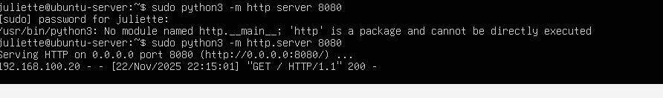
Screenshot – Wireshark Capture (Ubuntu Web Server Traffic)
(Wireshark capture showing SYN → SYN/ACK → ACK handshake)
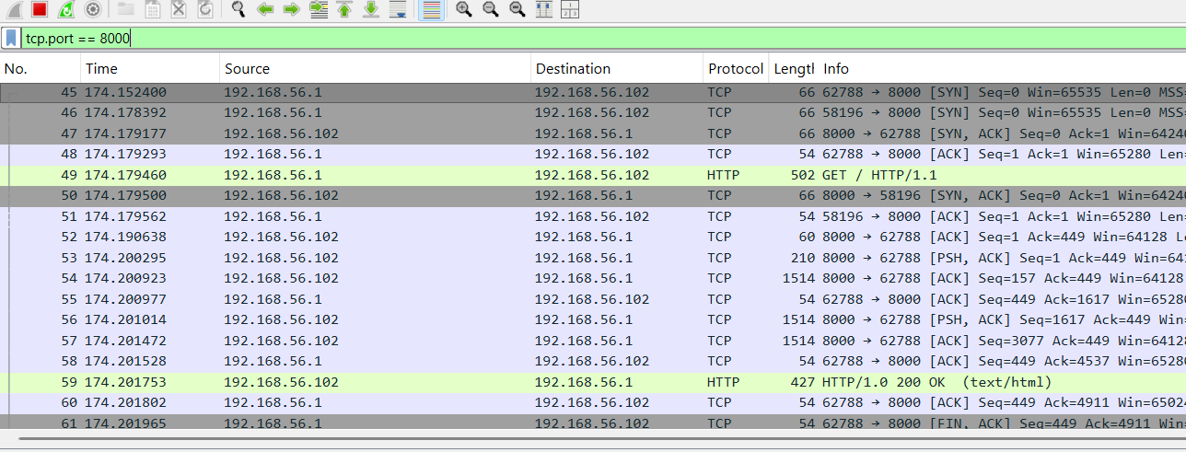

Screenshot – Ubuntu IPTables Rule for Web Server
(Insert screenshot of the Ubuntu NAT table showing the redirect rule)

MYSQL RULE — OPEN PORT 3306
Rule
sudo iptables -A INPUT -p tcp --dport 3306 -j ACCEPT
Why I Used It
MySQL needs port 3306 open for remote clients to connect.
Assumption
I assumed that an internal application or administrator needs to connect to MYSQL for database operations (for example, data entry, authentication, website backend).

Screenshot – Ubuntu IPTables MySQL Rule (This screenshot shows that port 3306 open on the Ubuntu server, meaning remote MySQL connections are permitted)
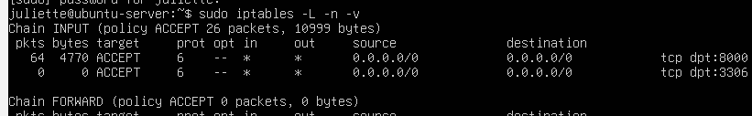

SSH ALLOW RULE
Rule
sudo iptables -A INPUT -p tcp --dport 22 -j ACCEPT
Why
System administrators need remote access through SSH.
Assumption
I assumed this is regular maintenance traffic from a trusted admin.
Screenshot – Windows Successful SSH Login (Ubuntu ALLOW)
( screenshot of successful login)
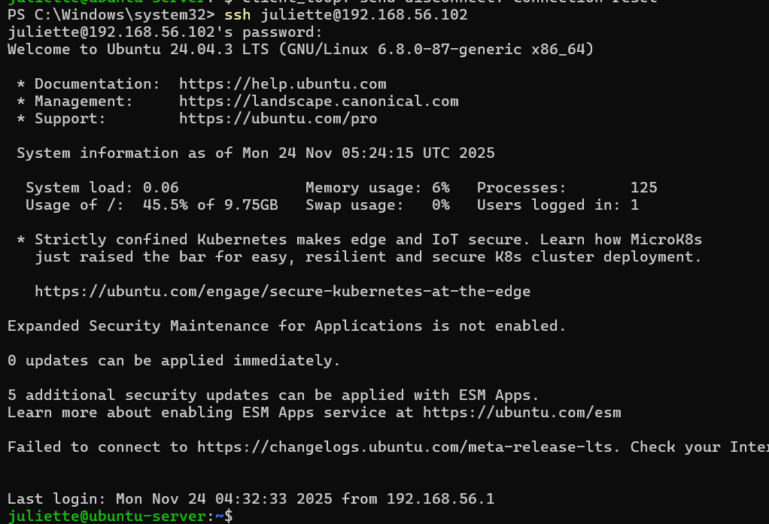
This screenshot shows my windows Computer successfully connecting to the Ubuntu server using SSH. I typed SSH juliette@192.168.56.102 and the server accepted the connection because port 22 was allowed by my IPTables rule. The Ubuntu server’s welcome banner confirms that the connection worked
Screenshot – Wireshark Capture (SSH Allowed)
( Wireshark sequence showing port 22 handshake)
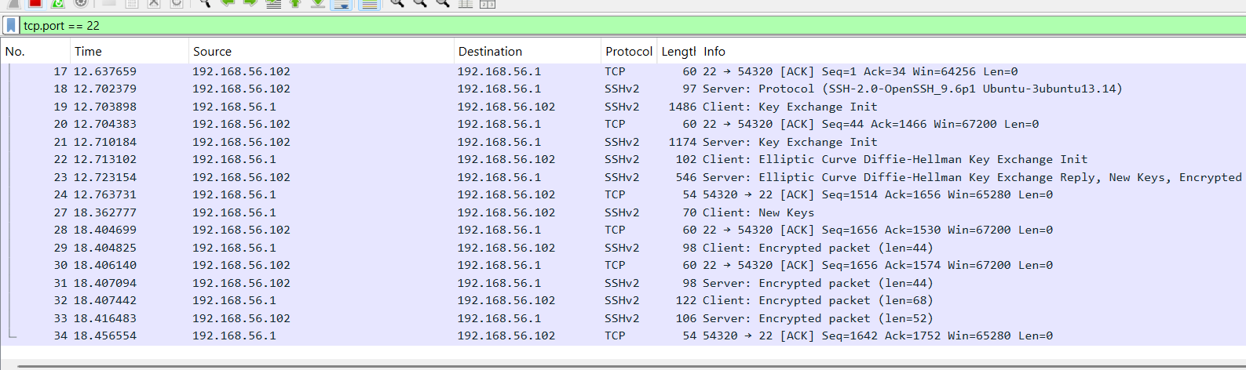

SSH DENY RULE
Rule
sudo iptables -A INPUT -p tcp --dport 22 -j DROP
Why
To block unauthorized remote access attempts.
Assumption
Someone could be trying to brute-force my SSH login.
Screenshot – Windows SSH Connection Denied (Ubuntu)
( screenshot showing time-out or “Connection refused”)
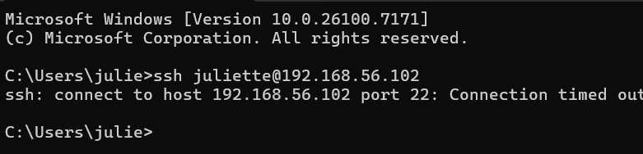

Screenshot – Wireshark Capture (SSH Dropped)
( capture showing repeated SYN packets with no SYN/ACK response)
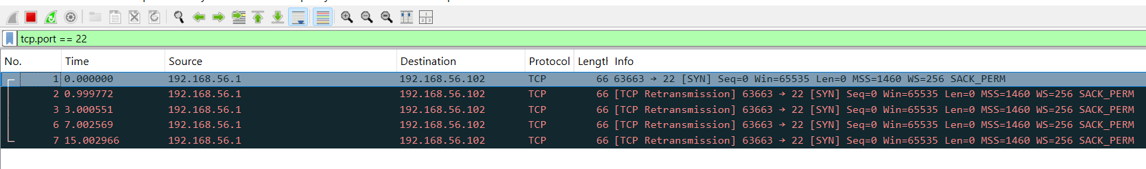

TELNET BLOCK RULE
Rule
sudo iptables -A INPUT -p tcp --dport 23 -j DROP
Why
Telnet is not secure and sends passwords in plain text . Attackers can use it to try to break into my server . Blocking port 23 protects the system
Assumption
I assume nobody on my system uses telnet normally, so any Telent traffic is unwanted and suspicious

Screenshot – Windows Telnet Test (Ubuntu)
(Insert screenshot showing "Could not open connection")
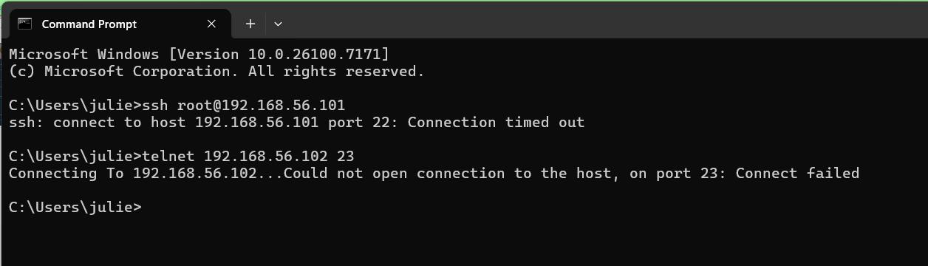
Screenshot – Wireshark Capture (Telnet Blocked)
( screenshot showing SYN requests only)
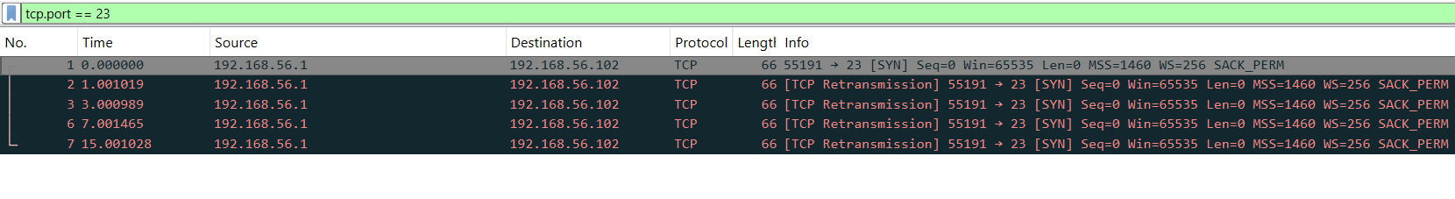
PING (ICMP) BLOCK RULE
Rule
sudo iptables -A INPUT -p icmp -j DROP
Why
Blocking ping prevents reconnaissance and network scanning.
Assumption
An attacker is scanning the network to see active hosts.

Screenshot – Windows PING Test (Ubuntu)
( screenshot showing "Request timed out")
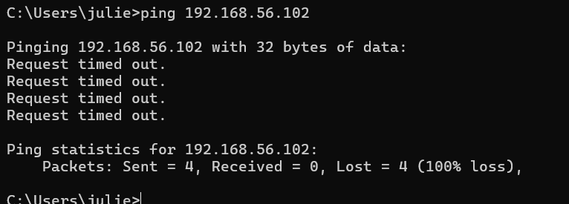
Screenshot – Wireshark Capture (ICMP Blocked)
(Insert screenshot showing Echo Request but no Echo Reply)
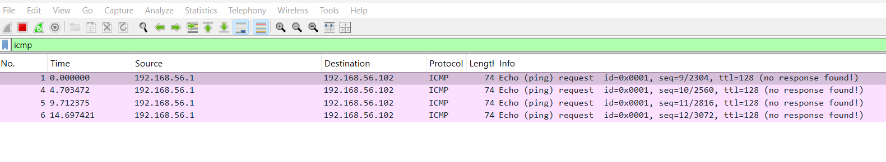
ALLOW/BLOCK SPECIFIC HOST & MAC ADDRESS
Allow Host IP
iptables -A INPUT -s 192.168.56.1 -j ACCEPT
Block Host IP
iptables -A INPUT -s 192.168.56.1 -j DROP
Allow MAC
iptables -A INPUT -m mac --mac-source 0A:27:00:00:00:00 -j ACCEPT

Reason:
To control which specific machine can communicate with my server .Useful for security and restricting access to only trusted devices
Assumption
Administrators need to permit trusted IP/MAC devices while blocking suspicious ones.

Screenshot – Host/MAC Rules (Ubuntu)
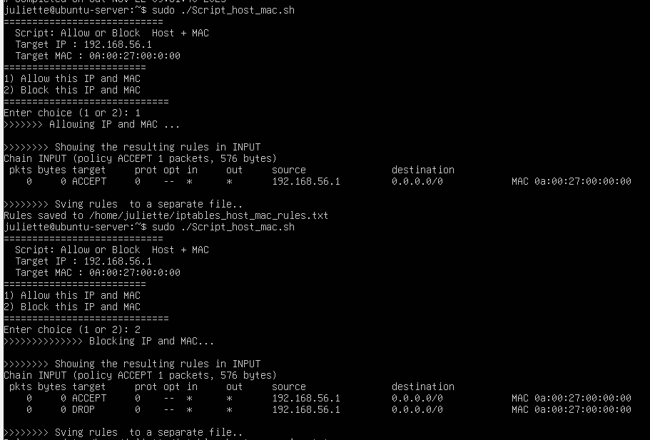

SECTION B — CENTOS SERVER
WEB SERVER RULE (OPEN PORT 80 + REDIRECT TO 8080)
Firewall Rule Used
sudo iptables -t nat -A PREROUTING -p tcp --dport 80 -j REDIRECT --to-port 8080
sudo iptables -A INPUT -p tcp --dport 8080 -j ACCEPT
Why I Used This
This rule redirects normal web traffic (port 80) to a custom port (8080).
This is helpful when using Python Simple HTTP Server or testing alternate web services.
Assumption (What I am dealing with)
I assumed a user is trying to access my web server. My goal is to make sure the web server stays available and receives traffic normally, even though it is running on port 8080 internally.
Screenshot – Windows Browser Accessing the Web Server (CentOS)
(Insert: The successful webpage that loaded using http://192.168.56.101:80)
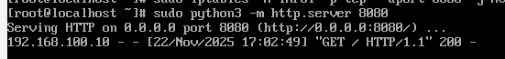

Screenshot – Wireshark Capture (CentOS Web Server Traffic)
(Wireshark capture showing SYN → SYN/ACK → ACK handshake)
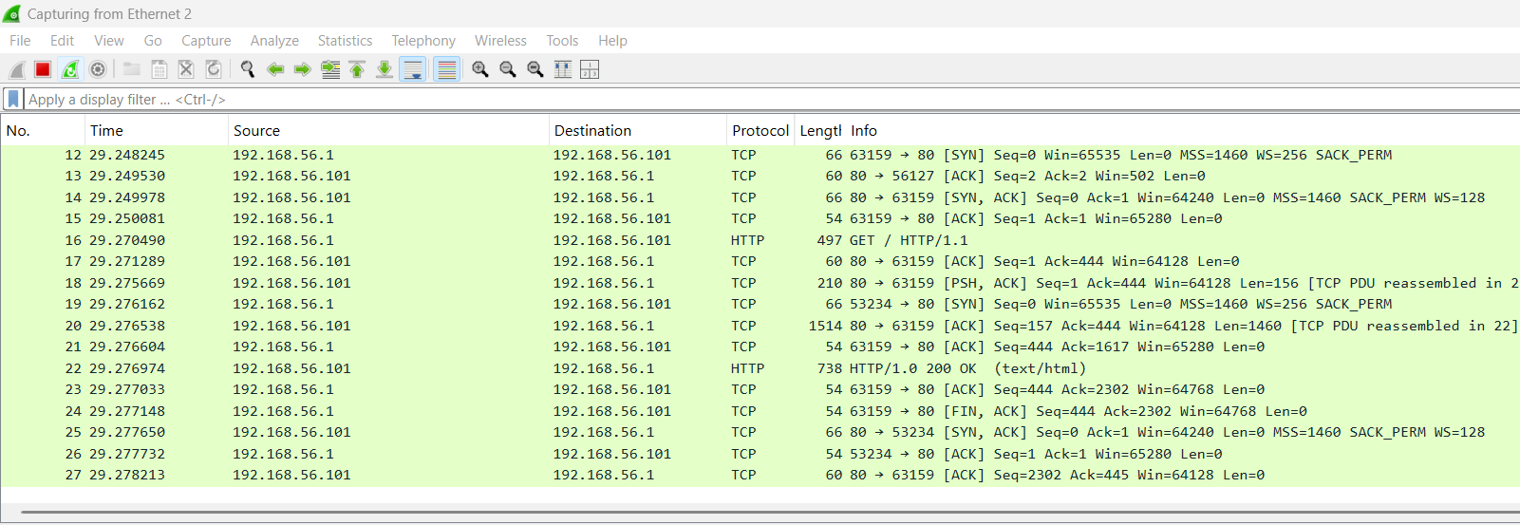
Screenshot – CentOS IPTables Rule for Web Server
( screenshot of the NAT tables showing the redirect rule)
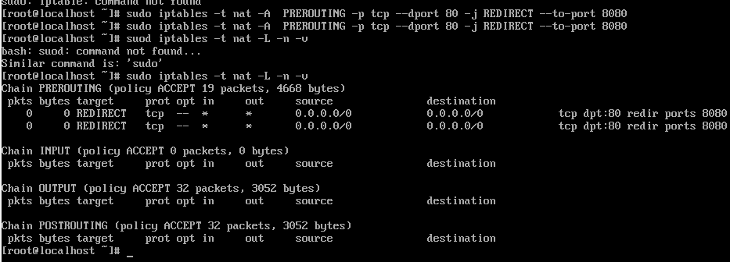

MYSQL RULE — OPEN PORT 3306
Rule
sudo iptables -A INPUT -p tcp --dport 3306 -j ACCEPT
Why I Used It
MySQL needs port 3306 open for remote clients to connect.
Assumption
I assumed that an internal application or administrator needs to connect to MYSQL for database operations (for example, data entry, authentication, website backend).
Screenshot – CentOS IPTables MySQL Rule (This screenshot shows that port 3306 open on the CentOS server, meaning remote MySQL connections are permitted)
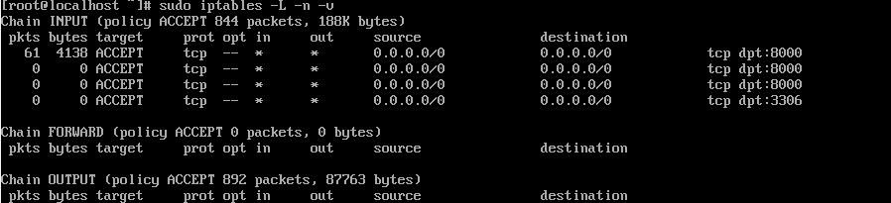

SSH ALLOW RULE
Rule
sudo iptables -A INPUT -p tcp --dport 22 -j ACCEPT
Why
System administrators need remote access through SSH.
Assumption
I assumed this is regular maintenance traffic from a trusted admin.
Screenshot – Windows Successful SSH Login (Centos ALLOW)
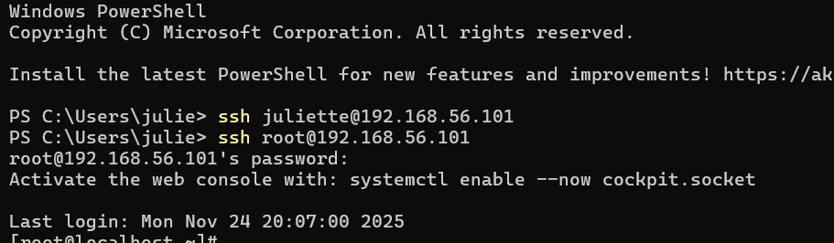
This screenshot shows my windows Computer successfully connecting to the Ubuntu server using SSH. I typed SSH root@192.168.56.101 and the server accepted the connection because port 22 was allowed by my Iptables rule. The CentOS server’s welcome banner confirms that the connection worked
Screenshot – Wireshark Capture (SSH Allowed)
( Wireshark sequence showing port 22 handshake)
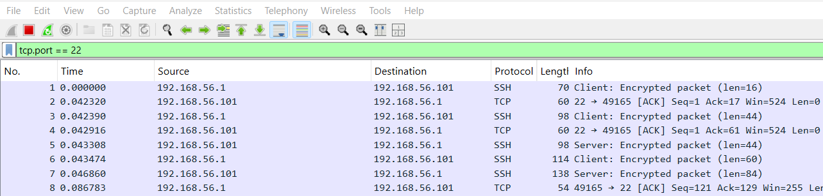

SSH DENY RULE
Rule
sudo iptables -A INPUT -p tcp --dport 22 -j DROP
Why
To block unauthorized remote access attempts.
Assumption
I assumed this SSH traffic was suspicious external access that should not be allowed
Screenshot – Windows SSH Connection Denied (Ubuntu)
( screenshot showing time-out or “Connection refused”)
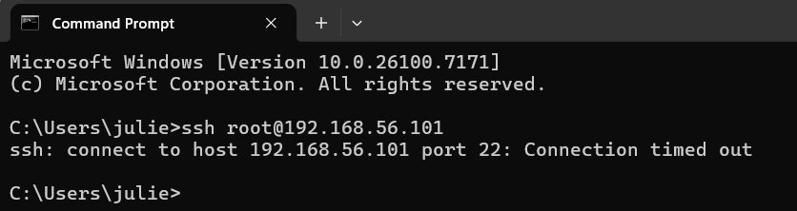
Screenshot – Wireshark Capture (SSH Dropped)
( capture showing repeated SYN packets with no SYN/ACK response)
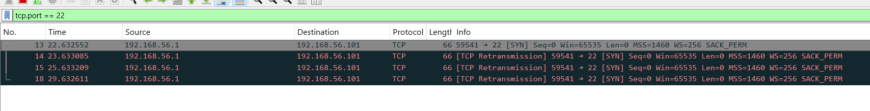
PING (ICMP) BLOCK RULE
Rule
sudo iptables -A INPUT -p icmp -j DROP
Why
Blocking ping prevents reconnaissance and network scanning.
Assumption
An attacker is scanning the network to see active hosts.

Screenshot – Windows PING Test (CentOS)
( screenshot showing "Request timed out")
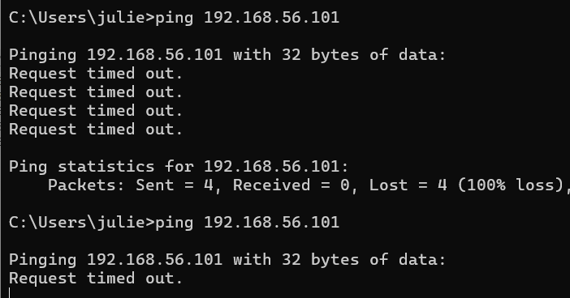

Screenshot – Wireshark Capture (ICMP Blocked)
(Insert screenshot showing Echo Request but no Echo Reply)
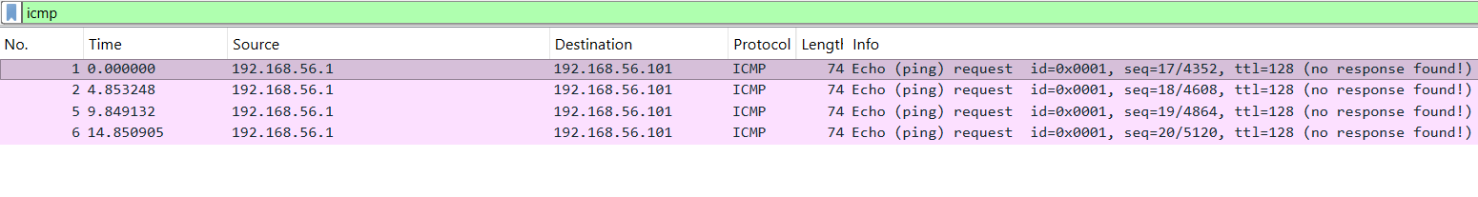
TELNET BLOCK RULE
Rule
sudo iptables -A INPUT -p tcp --dport 23 -j DROP
Why
Telnet is not secure and sends passwords in plain text . Attackers can use it to try to break into my server . Blocking port 23 protects the system
Assumption
I assume nobody on my system uses telnet normally, so any Telent traffic is unwanted and suspicious

Screenshot – Windows Telnet Test (Centos)
(Insert screenshot showing "Could not open connection")
Screenshot – Wireshark Capture (Telnet Blocked)
( screenshot showing SYN requests only)

ALLOW/BLOCK SPECIFIC HOST & MAC ADDRESS
Allow Host IP
iptables -A INPUT -s 192.168.56.1 -j ACCEPT
Block Host IP
iptables -A INPUT -s 192.168.56.1 -j DROP
Allow MAC
iptables -A INPUT -m mac --mac-source 0A:27:00:00:00:00 -j ACCEPT
iptables -A INPUT -m mac --mac-source 0A:27:00:00:00:00 -j DROP

Reason:
To control which specific machine can communicate with my server .Useful for security and restricting access to only trusted devices
Assumption
Administrators need to permit trusted IP/MAC devices while blocking suspicious ones.

Screenshot – Host/MAC Rules (CentOS)
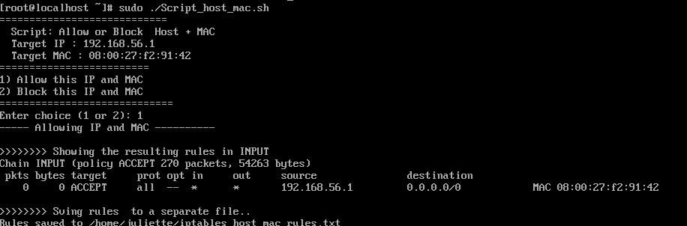

PART2 – IP TABLE DOCUMENTATION
This document provides:
- A list of the changes I made to firewall rules on each server
- Which table each change affected(filter or NAT)
- When the change was made (date/time or during testing)
- A copy of the original IP Tables before any modification
- A copy of the updated IP Tables after each modification
UBUNTU SERVER – List OF Changes to IPTables
2- Change: Web server Port Forwarding (80- 8080)
Change Made: Added NAT PREROUTING redirect rule for web server
Table Modified: NAT
Chain Modified: PREROUTING
Table that needs change: NAT because port forwarding occurs in NAT
Date: 11/22/25 – 11:00PM
B - MYSQL Rule (Allow Port 3306)
Change Made: Allowed inbound MYSQL traffic
Table Modified: Filter table
Chain Modified: INPUT
Table that needed this change :Filter, Because MYSQL traffic needs to be allowed through INPUT
Date/ Time: 11/23/2025 – 11:10PM

C. SSH Allow Rule
Change Modified: Allowed inbound SSH port 22
Table Modified: Filter
Table I think needs modification: Filter, Because SSH is a regular incoming connection – not NAT
Date/ Time: 11/23/2025 – 11:20PM
D. SSH Deny Rule
Change Made: Blocked inbound SSH on port 23
Table Modified: Filter
Chain Modified: INPUT

Table that needs change: Filter, because DROP rules after incoming packet filtering
Date/ Time: 11/23/2025 – 11:30PM

E. Ping Block
Change: Dropped ICMP echo-request packet
Table changed: Filter table
Chain: INPUT
Table That Needs change :Filter, because filtering ICMP happens in the filter table
Date/ Time: 11/23/2025 – 11:40PM

F. Block Telnet (Port 23)
Change Made : Block Telnet on port 23
Table Modified : Filter
Chain : INPUT
Table that needs changed: Filter, because Telnet blocking is a filtering task
Date/ Time: 11/23/2025 – 11:50PM

G. Allow/ Block Specific Host and MAC Address
Change Made: Allow Specific Host:192.168.56.1
Table Modified :Filter
Table that Needed this Change: Filter, because IP and MAC filtering is always done at the packet filtering level
Date/ Time: 11/23/2025 – 12:00AM
H. Block Specific MAC address
Change Made: block specific MAC address 00:12:23:00:00 using script
Table Modified :Filter
Chain Modified: INPUT
Table that Needed this Change: Filter, because IP and MAC filtering is always done at the packet filtering level
Date/ Time: 11/23/2025 – 12:00AM

Section B – CentOS Server- List of Changes Made
Change: Web server Port Forwarding (80- 8080)
Change Made: Added NAT PREROUTING redirect rule for web server
Table Modified: NAT
Chain Modified: PREROUTING
Date: 11/22/25 – 11:00PM
B - MYSQL Rule (Allow Port 3306)
Change Made: Allowed inbound MYSQL traffic
Table Modified: Filter table
Chain Modified: INPUT
Table that needed this change :Filter, because MYSQL traffic needs to be allowed through INPUT
Date/ Time: 11/23/2025 – 11:10PM

C. SSH Allow Rule
Change Modified: Allowed inbound SSH port 22
Table Modified: Filter
Chanin Modified: INPUT
Table I think needs modification: Filter, Because SSH is a regular incoming connection – not NAT
Date/ Time: 11/23/2025 – 11:20PM
D. SSH Deny Rule
Change Made: Blocked inbound SSH on port 23
Table Modified: Filter
Chain Modified: INPUT
Table that needs change: Filter, because DROP rules after incoming packet filtering
Date/ Time: 11/23/2025 – 11:30PM

E. Ping Block
Change: Dropped ICMP echo-request packet
Table changed: Filter table
Chain: INPUT
Table That Needs change :Filter, because filtering ICMP happens in the filter table
Date/ Time: 11/23/2025 – 11:40PM

F. Block Telnet (Port 23)
Change Made : Block Telnet on port 23
Table Modified : Filter
Chain : INPUT
Table that needs changed: Filter, because Telnet blocking is a filtering task
Date/ Time: 11/23/2025 – 11:50PM

G. Allow/ Block Specific Host and MAC Address
Change Made: Allow specific IP: 192.168.56.1
Table Modified :Filter
Chain Modified: INPUT
Table that Needed this Change: Filter, because IP and MAC filtering is always done at the packet filtering level
Date/ Time: 11/23/2025 – 12:00AM
H. Block Specific MAC address
Change Made: block specific MAC address 00:12:23:00:00 using script
Table Modified :Filter
Chain Modified: INPUT
Table that Needed this Change: Filter, because IP and MAC filtering is always done at the packet filtering level
Date/ Time: 11/23/2025 – 12:00AM

Copy of Original and Updated IP Tables
Ubuntu default iptables
Sudo iptables -L -n -v
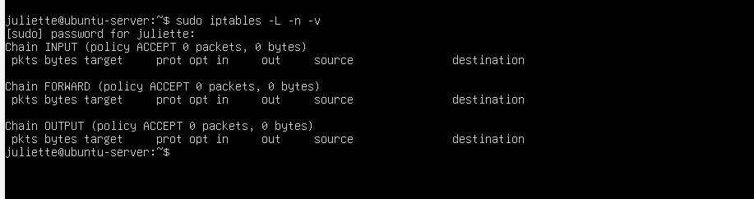
Sudo iptables -t nat -L -n -v
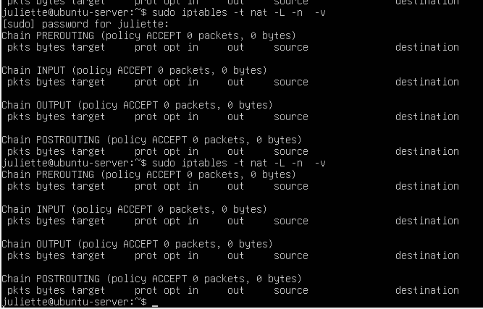
Update IPTables
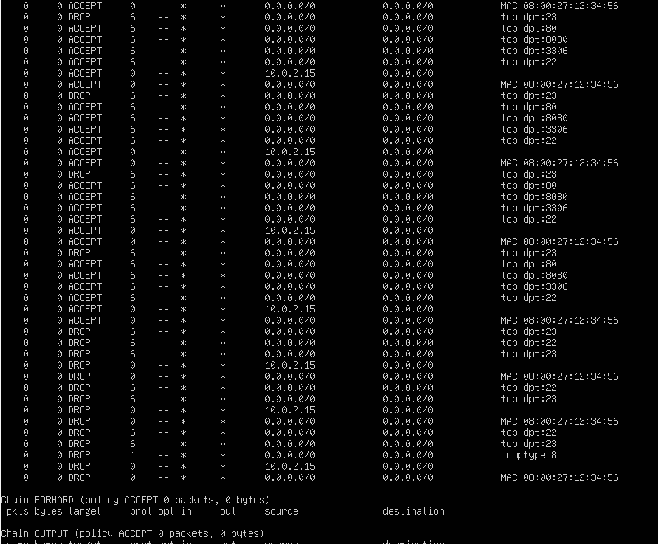
CentOS Default Iptables
Sudo iptables -L -n -v
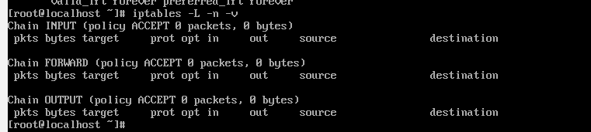
NAT
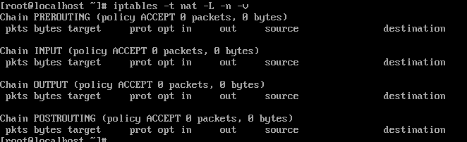

Updated IPTables
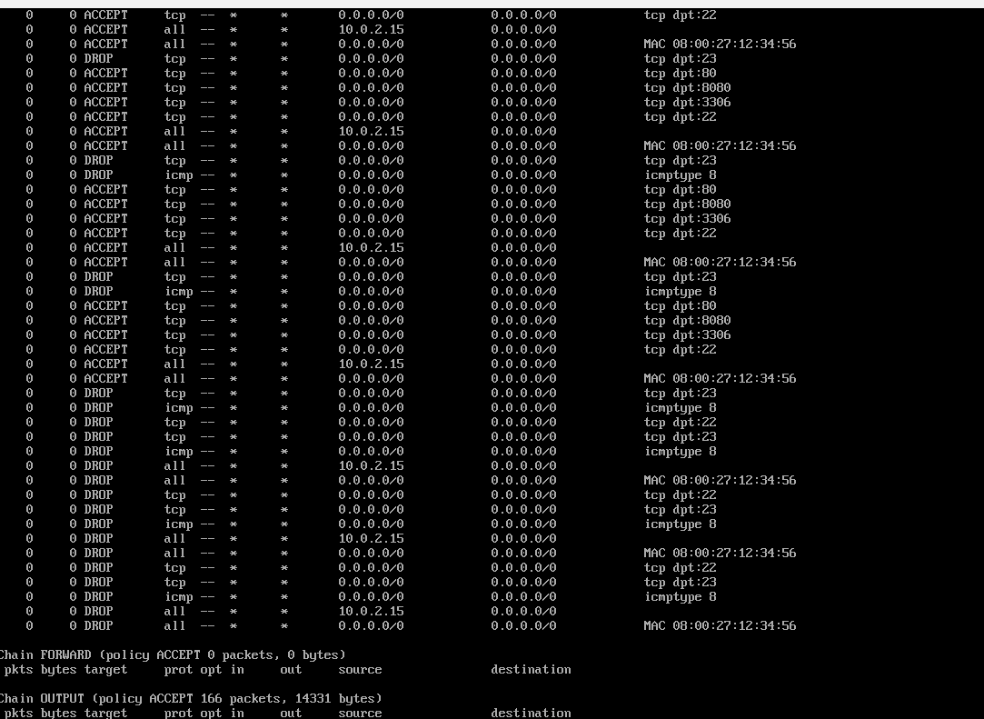

How to Prevent DDOS Attacking Using IPTables:

A Distributed Denial-of-Service attack happens when many computers of bots send huge amounts of traffic to a server at the same time to overload it and make it unreachable. One simple way to reduce the impact of these attacks is by using IPTables to control and limit incoming traffic. With iptables, I can limit how many connections a single IP address can make and slow down suspicious traffic before it reaches my services. This helps protect my server from being overloaded
Another way iptables helps is by dropping or rejecting packets that look abnormal or are coming in too fast . By setting rate limits or connection limits, iptables forces attackers to slow down. It also allows me to block known bad Ip addresses quickly, so they cannot attack my system
Overall, iptables does not completely stop every DDos attack, but reduces the damage enough for a server to stay online long enough to detect the problem, gather logs and apply stronger security methods. It is a simple and effective first layer for any Linux server

References:
DigitalOCean: “How to List and Delete IPTable FireWall Rules” https://www.digitalocean.com/community/tutorials/how-to-list-and-delete-iptables-firewall-rules
Ubuntu Documentation. Firewall with IPTables .
Retrieved from
https://help.ubuntu.com/community/IptablesHowTo
Linode. Control Network Traffic with IPTables
Retrieves from
Controlling Network Traffic with iptables - A Tutorial | Linode Docs

2- GeeksforGeeks-“DDoS Attack Explained” https://www.geeksforgeeks.org/distributed-denial-of-service-ffos-attack/

